A Bus has the following attributes:
passengers (int), should be greater or equal 0 and smaller or equal seats, default 0
seats (int), should be greater or equal 0, default 50
vehicle registration number (String) (short: registration), should have 8 letters. Default: “AB00 ABC”. It is specified as follows:
The current format for vehicle registration numbers was introduced on 1 September 2001 for all new vehicles being registered. The format is two letters, two numbers, a space and three further letters.
The first two letters are the DVLA memory tag, the two numbers (the age identifier) indicate the age of the vehicle, and the last three letters are random.
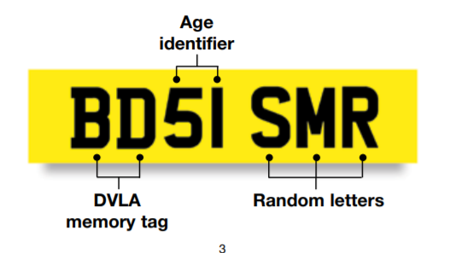
For example, BD signifies Birmingham, 51 represents September 2001 and SMR are random letters. The age identifier changes every six months in March and September.
https://assets.publishing.service.gov.uk/government/uploads/system/uploads/attachment_data/file/359317/INF104_160914.pdf
Create a checkConsistency method and use it in the other methods and constructors as appropriate.
For the registration you should check if the characters at positions 0,1,5,6 and 7 are upper case letters, at positions 2 and 3 are digits, and at position 4 there is a space.
There should be a constructor with 3 parameters, and a constructor with no parameters.
There should be getters and setters for all fields.
The method int enter(int number) has number passengers get on the bus. Make sure that the number of available seats is not exceeded. Standing on the bus is not allowed. The method returns the number of passengers that have actually entered the bus. Check that the parameter is greater than 0.
The method int exit(int number) has number passengers get off the bus. Make sure that only passengers actually in the bus can get off it. Returns the number of passengers actually getting off the bus. Check that the parameter is greater than 0.
There is a print method that prints a description of the bus (i.e. its fields’ values).
A BusStop has up to 3 buses.
There are 3 fields of class Bus called b0, b1 and b2.
There is one constructor with no parameters that initializes the fields as follows:
b0: 0, 20, “MA73 EHI”
b1: null
b2: 12, 40, “YD34 HIF“
The method Bus maxSeats() finds the bus with the most seats.
The method int registrationStartsWith(String s) finds how many buses’ registration numbers start with the characters given in the parameter (hint: there is a String method called startsWith).
The method int enter(int passengers) has a number of passengers enter the buses. It returns the number of passengers that have actually entered. Passenger should first enter b0. Those that don’t find a seat in b0 try b1, and so on.
Bus getBus(int position): returns the Bus at the indicated position, or null, if position is not between 0 and 2.
boolean addBus(Bus b): adds the Bus to the BusStop, if there is room (i.e. one of the 3 attributes is null).
Check that you don‘t add the same Bus twice, and that b is not null. Returns true if the Bus was successfully added, false otherwise.
boolean addBus(Bus b, int position): Same as above, at the specified position. position is between 0 and 2.
Bus removeBus(): remove the first Bus from the BusStop (i.e. value of the first attribute that is not null). Returns the removed bus or null.
Bus removeBus(int position): Same as above, at the specified position.

There is a Test class with a test method.
In the test method:
create a BusStop.
Call the maxSeats method and check if it’s result’s maxSeats is 40.
Call registrationStartsWith(“YD”) and check if the result is 1.
Call the method enter(30) and check if the result is 30.
Call the method getBus(2) and check if the result’s number of passengers is 22.
Call the method remove and check if the result’s number of passengers is 20.
Create a Bus with parameters 15, 35, “LD23 JKL” and store it in a variable c.
Create a Bus with parameters 18, 55, “OD76 ERT” and store it in a variable d.
Add c to the BusStop at position 0.
Add c to the BusStop again. There should be an error message.
Add d to the BusStop.
Remove a Bus. Check if the result is c.
Remove the Bus at position 1. Check if the result is d.

